Test Case: tc002_SPX_Dev5_Crear_Requisicion_Spot_Tipo_Cobro_Project
Step 1 - Enter username and password and click to button Enter: Credentials Entered
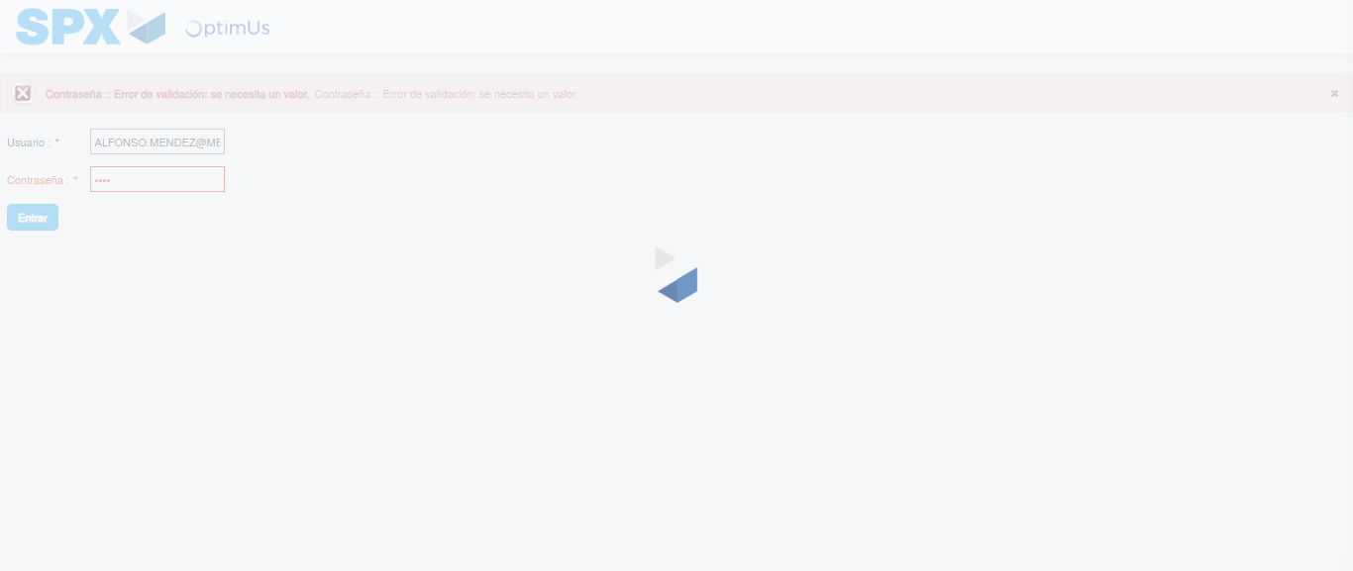Image file-name: QC_Testing-tc002_SPX_Dev5_Crear_Requisicion_Spot_Tipo_Cobro_Project-1784307038574

Step 2 - Select to UEN and Access to Spot Buy Requisitions : UEN Correctly selected and Correct access
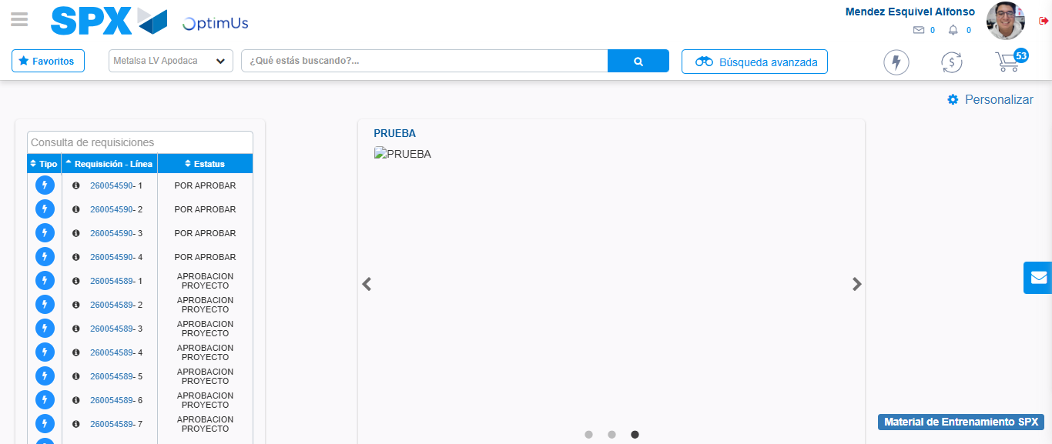Image file-name: QC_Testing-tc002_SPX_Dev5_Crear_Requisicion_Spot_Tipo_Cobro_Project-1784307111723

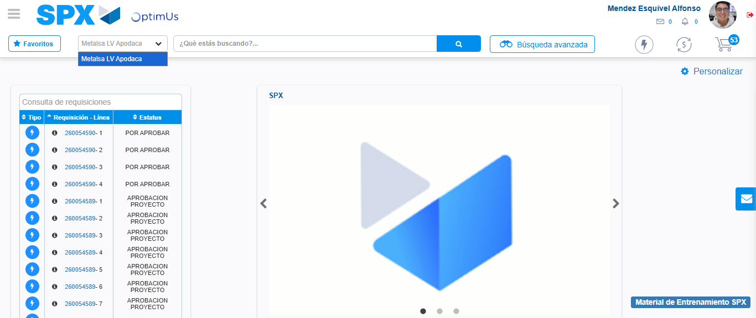Image file-name: QC_Testing-tc002_SPX_Dev5_Crear_Requisicion_Spot_Tipo_Cobro_Project-1784307114265

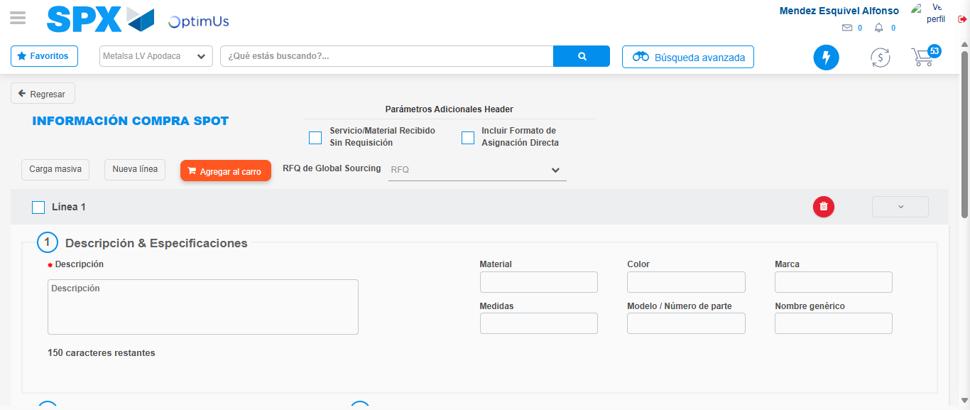Image file-name: QC_Testing-tc002_SPX_Dev5_Crear_Requisicion_Spot_Tipo_Cobro_Project-1784307142171

Step 3 - Data Capture Spot Buy Requisition: Data captured correctly
Image file-name: QC_Testing-tc002_SPX_Dev5_Crear_Requisicion_Spot_Tipo_Cobro_Project-1784307142385

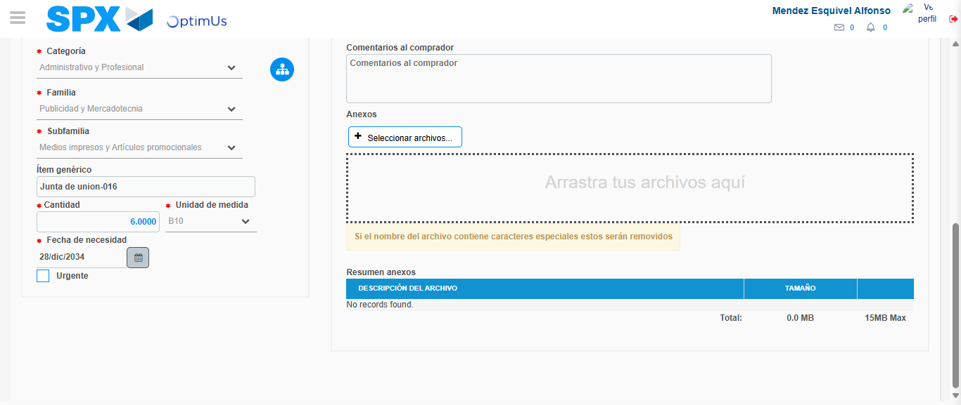Image file-name: QC_Testing-tc002_SPX_Dev5_Crear_Requisicion_Spot_Tipo_Cobro_Project-1784307154115

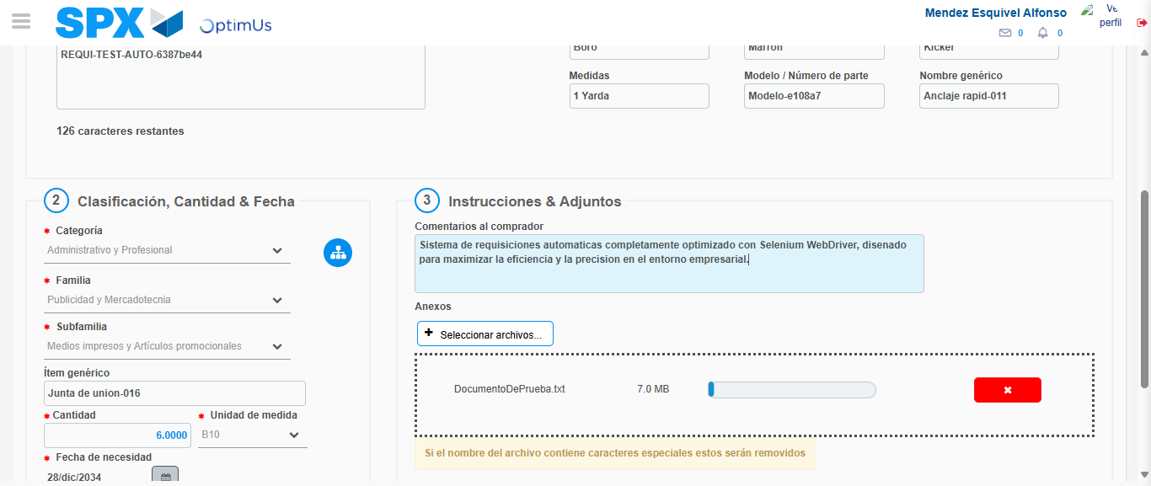Image file-name: QC_Testing-tc002_SPX_Dev5_Crear_Requisicion_Spot_Tipo_Cobro_Project-1784307154899

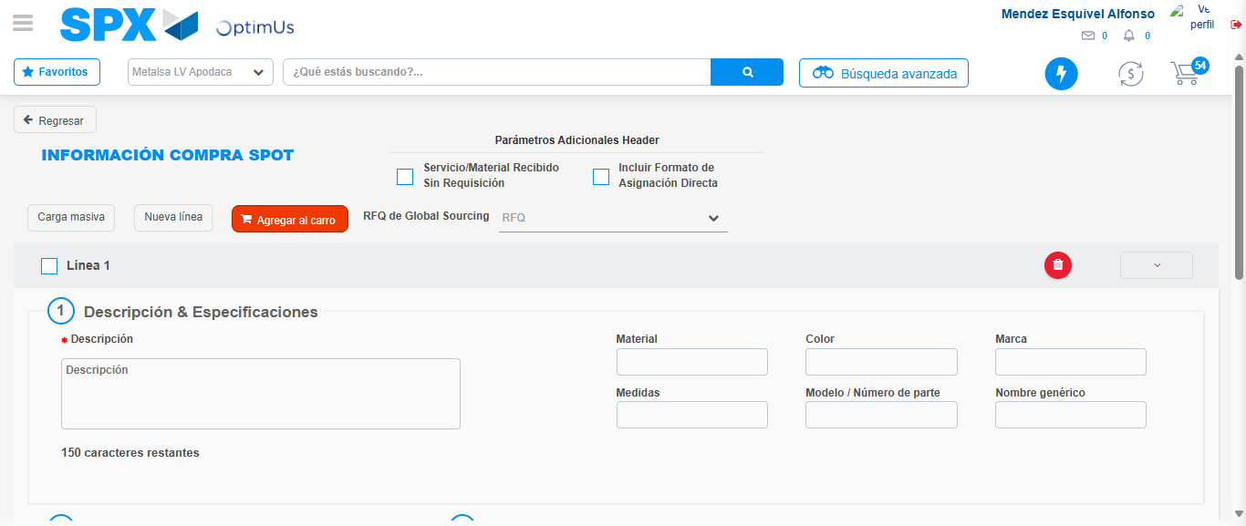Image file-name: QC_Testing-tc002_SPX_Dev5_Crear_Requisicion_Spot_Tipo_Cobro_Project-1784307163840

Step 7 - Return to Main Page SPX : Return to Main Page SPX
Image file-name: QC_Testing-tc002_SPX_Dev5_Crear_Requisicion_Spot_Tipo_Cobro_Project-1784307111723

Image file-name: QC_Testing-tc002_SPX_Dev5_Crear_Requisicion_Spot_Tipo_Cobro_Project-1784307114265

Image file-name: QC_Testing-tc002_SPX_Dev5_Crear_Requisicion_Spot_Tipo_Cobro_Project-1784307142171

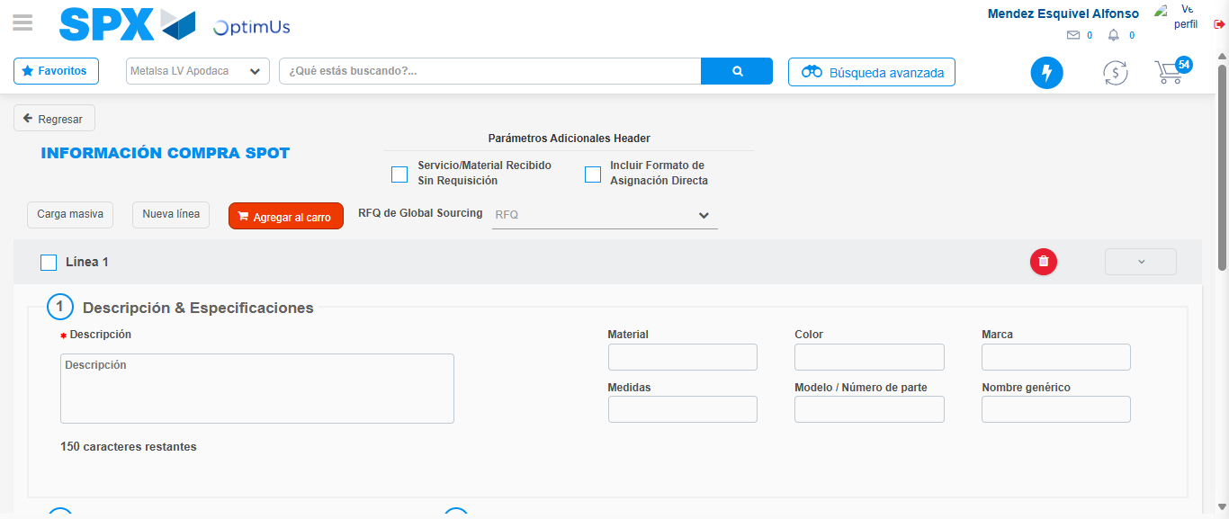Image file-name: QC_Testing-tc002_SPX_Dev5_Crear_Requisicion_Spot_Tipo_Cobro_Project-1784307166022

Image file-name: QC_Testing-tc002_SPX_Dev5_Crear_Requisicion_Spot_Tipo_Cobro_Project-1784307166138

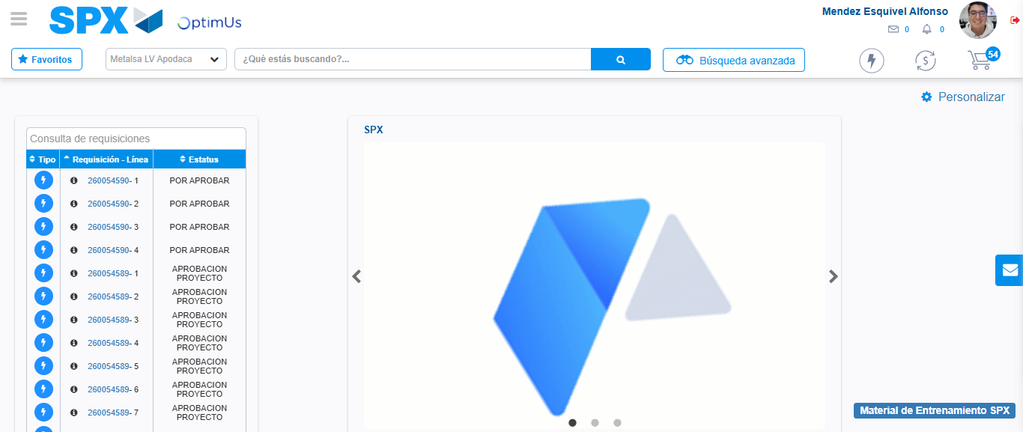Image file-name: QC_Testing-tc002_SPX_Dev5_Crear_Requisicion_Spot_Tipo_Cobro_Project-1784307187284

Step 8 - Log Out : Log Out SPX
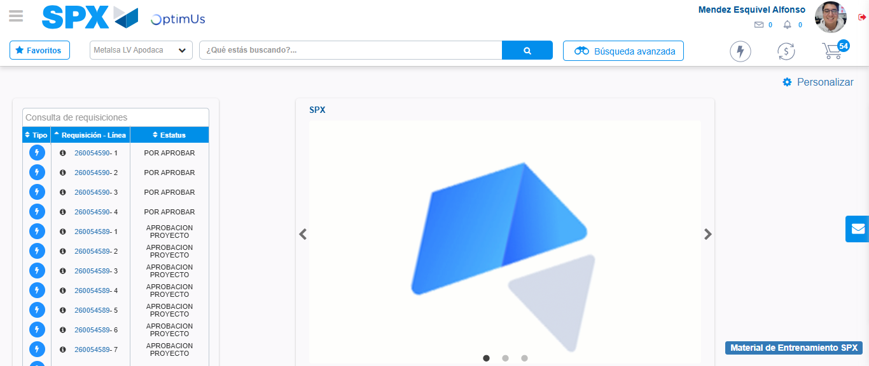Image file-name: QC_Testing-tc002_SPX_Dev5_Crear_Requisicion_Spot_Tipo_Cobro_Project-1784307187554

